Given the root of a binary tree, each node in the tree has a distinct value.

After deleting all nodes with a value in to_delete, we are left with a forest (a disjoint union of trees).

Return the roots of the trees in the remaining forest.  You may return the result in any order.

**Example 1:**

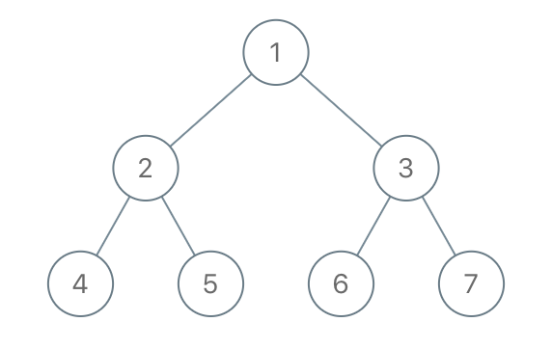

**Input:** root = [1,2,3,4,5,6,7], to_delete = [3,5]

**Output:** [[1,2,null,4],[6],[7]]

**Constraints:**

* The number of nodes in the given tree is at most 1000.
* Each node has a distinct value between 1 and 1000.
* to_delete.length <= 1000
* to_delete contains distinct values between 1 and 1000.